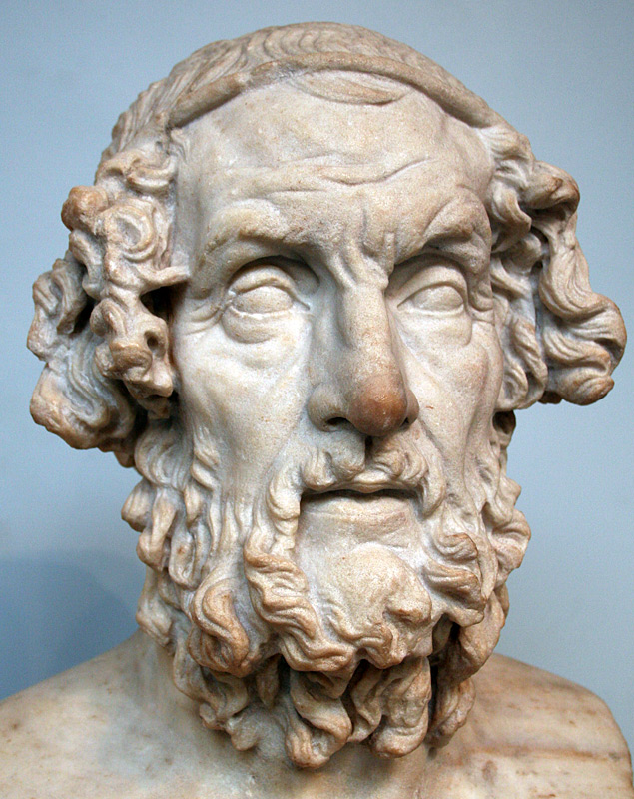
Ancient Greece Trading Cards
Homer’s Odyssey
------------------------------------------------------
Due Date: Thursday, December 20th

Assignment:
- Create a poster for your assigned Ancient Greece topic. The poster should provide crucial information about the topic in a neat, organized, and engaging manner.

- The “MVP” poster for each topic (as voted on by students/ teachers) will receive extra credit and will be used as a resource for the grade.

- You may work alone or in a pair. * Image from: en.wikipedia.org

- We will work on this in class for two days. Topics will be chosen out of a hat.

Requirements Checklist:
- at least one large, relevant visual (ex// a picture, a drawing, a map, a chart, etc.).
- a list of MLA formatted citations (alphabetized by author’s last name) on the back of the poster
- at least two digital sources of information
- a neat, visually pleasing poster (this can be 2-4 pieces of computer paper taped together)
- satisfy the information requirements for your topic (see back of paper).

Grading (25 pts): Formative Assessment

- Content (15 pts): All content requirements listed below are covered thoroughly and accurately. The content is given enough context (background information) so that the rest of the class understands.

- Visual Presentation (7 pts): Presentation is neat and visually appealing. Information is logically organized and split into understandable sections. Presentation includes a relevant visual that helps to deepen understanding of the topic.

- Citation (3 pts): Sources are properly cited according to MLA format.

TRADING CARD TOPICS

GODS | RITUALS | BELIEFS
- Athena  - Zeus  - Hermes  - Poseidon | - Xenia  - Animal Sacrifice | - Greek Warfare  - The Fates  - Hubris

TRADING CARD INFORMATION REQUIREMENTS

1. Athena / 2. Zeus / 3. Hermes / 4. Poseidon:
- God’s main symbol(s) and a brief explanation of each symbol’s significance.
- God’s main domain (s)/ power(s).
- At least one of the god’s nicknames and an explanation.
- Three personality traits/ characteristics (if possible, include examples from stories).

5. Xenia / 6. Animal Sacrifice:
- Describe the ritual (Who, What, When, Where, Why)
- Explain how the ritual affected daily life of the Greeks, if you haven’t done so.
- Introduce a new vocabulary word (and its definition!) that is relevant to the ritual.

7. Ancient Greek Warfare:
- Explain the extent to which belief in the Greek gods influenced Greek warfare.
- Explain how ancient Greek communities felt about war and why. Be specific.
- Introduce a new vocabulary word (and its definition!) that is relevant to Greek warfare.

8. The Fates:
- Describe each of the three Fates and their roles.
- Explain how belief in the Fates affected Greek beliefs about destiny and control.

9. Hubris:
- Define hubris.
- Provide three examples of hubris, either from ancient Greek tales or from the modern world.

RELIABLE RESOURCES (start here!):
- Official History Channel Website: http://www.history.com
- Metropolitan Museum Website: www.metmuseum.org
- Encyclopedia Britannica: www.britannica.com
- Ancient History Encyclopedia: http://www.ancient.eu/

